1. Go to Tcode SE11. Select Radio Button Domain. Click on create.

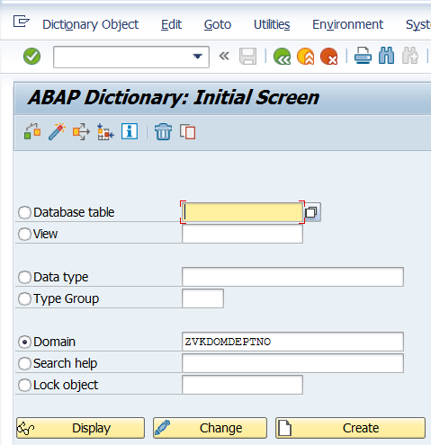

Choose Domain

Click Create

Specify the Domain Name starting with Y or Z

Tcode : SE11

1. Select Data Type and No. Characters. Save and Activate.

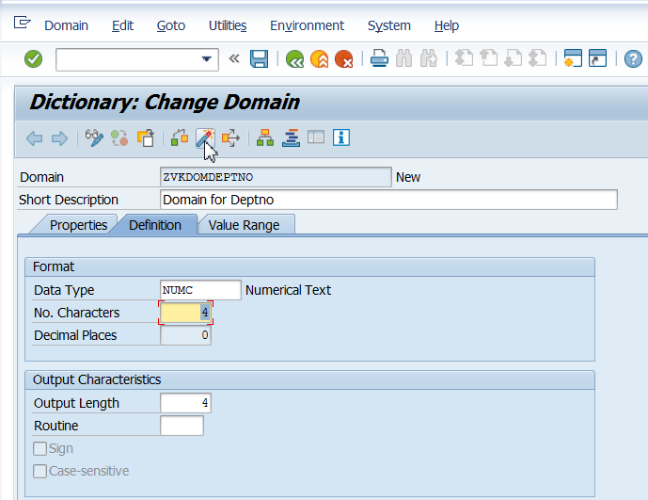

1. This domain can be used in any Data Element. Refer to the existing data element and use the domain instead of Predefined Data Type.

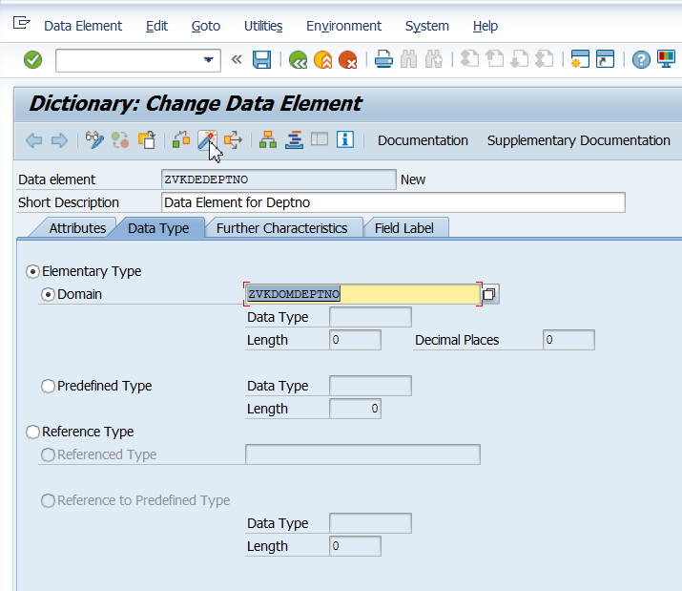

Save and activate the Data Element